


CMS – Supplementary FSD

Table of Contents
User Stories 1
1. Alert Triage Module 2
1-A Auto-Trigger Triage Task for New Alerts 2
1-B Auto-Close False Positive Alert with No Transaction or AML Suspicion 2
1-C Auto-Close True Positive Alert 2
1-D Investigate Confirmed Alert with Transaction Occurrence 3
1-E Investigate Confirmed Alert with Money Laundering Suspicion 3
1-F Investigate Alert with Low Confidence Prediction 3
1-G Default to Manual Investigation When No Confidence Threshold is Configured 3
1-H Bypass Triage If Module is Disabled 4
1-I Split Cases for Fraud and AML Investigations 4
1-J Prioritize Alerts for Investigation Based on Configurable Attributes 4
API Specs: 5
2. Create a New Case 5
2-A Case Creation by Analyst 5
2-B Case Creation by Supervisor 5
2-C Case Creation by API Portal 6
2-D Case Creation Failure (Due to Missing Information) 6
2-E Case Creation Abandonment 6
API Specs: 6
3. Complete Case Creation 7
3-A Completing a Saved Case Creation 7
3-B Case Update Failure During Completion 7
3-C Abandoning a Saved Case 7
API Specs: 7
4. Approve Case Creation 7
4-A Supervisor Approves Case Creation 8
4-B Supervisor Rejects Case Creation 8
4-C Supervisor Approval Failure 8
API Specs: 8
5. Assign (Reassign) a Task 9
5-A Assigning a Task to a User 9
5-B Reassigning a Task to Another User 9
5-C Task Assignment Failure 9
5-D Task Assignment to Invalid User 9
API Specs: 10
6. Investigate a Case 10
6-A Preliminary Investigation 10
6-B Investigating a Case 10
6-C Task Suspension During Investigation 10
6-D Reassigning an Investigation Task 11
6-E Case Investigation Completion 11
6-F Investigation Task Failure 11
6-G Risk Assessment 11
6-H Collect and Analyze Evidence 12
6-I Document Investigation Findings 12
6-J File SAR/STR Report 12
6-K Failure to Retrieve Evidence 13
6-L False Positive Alert Handling (Failure Scenario) 13
6-M Failure to Meet Regulatory Reporting Deadline 14
6-N Escalation of Suspicious Findings During the Investigation 14
6-O Fraud Investigation Outcome - No Fraud Detected (Failure Scenario) 15
6-P Report Generation for Regulatory Compliance 15
API Specs: 15
7. Unassign a Task 16
7-A Unassigning a Task 16
7-B Unassign Task Failure 16
API Specs: 16
8. Suspend a Case 16
8-A Suspending a Case 16
8-B Case Suspension Failure 17
API Specs: 17
9. Resume a Case 17
9-A Resuming a Suspended Case 17
9-B Resume Case Failure 17
API Specs: 17
10. Close a Case 18
10-A Closing a Case 19
10-B Closing a Case without Approval 19
10-C Case Closure Failure 19
API Specs: 19
11 Approve Case Closure 19
11-A Supervisor Approves Case Closure 19
11-B Supervisor Rejects Case Closure 20
11-C Case Closure Approval Failure 20
API Specs: 20
12. Reopen a Case 20
12-A Reopening a Case 20
12-B Case Reopening Failure 20
API Specs: 21
13. Approve Case Reopening 22
13-A Supervisor Approves Case Reopening 22
13-B Supervisor Rejects Case Reopening 22
API Specs: 22
14. Reporting 22
14-A Generate Reports 22
API Specs: 22
15. Case Queue and Work Queue Management 22
15-A Creating Work Queues 23
15-B Assigning Users to Work Queues 23
15-C Reassigning Tasks Between Work Queues 23
15-D Monitoring Task Progress in Work Queues 23
15-E Configuring Work Queue Rules 24
15-F System Notifications for Task Assignments 24
API Specs: 24
16. General Configuration Management 25
16-A System Configuration Management 25
16-B Auditing System Configuration Changes 25
API Specs: 25
Supporting Sequence Diagrams 25
1- Preliminary Investigation 26
2- Assess Risk and Predication: 26
3- Collect and Analyze Evidence 27
4- Compile Fraud Report 27
5- Assess AML Risk 28
6- Review EDD/KYC 28
7- File SAR/STR 29
8- Automatically Create and Route Triage Task 30
9- Flag Alerts for Investigation When Confidence Is Low 30
10- Automatically Close Alert with Confirmed Outcome 31
11- Auto-Split Cases for AML and Fraud 32
12- Auto-Close Alerts with False Positives 33
Prototype Highlights 34
1- Manual Case Creation Features 35
2- Alert Management 35
3- Logging Actions in an Alert 36
4- Escalation to Supervisor 36
5- Reassigning a Case 37
6- Case Suspension 38
Non-Functional Specifications 39
Auditability 39
Change Controls for Fields 39
Transactional History for Entities 39

User Stories

1. Alert Triage Module

1-A Auto-Trigger Triage Task for New Alerts
As a Case Management System, I want to trigger an AI-based triage task automatically upon receiving a new alert from the Transaction Monitoring System so that the system can predict whether the alert requires investigation or can be auto-closed.
- Acceptance Criteria:
  - The system creates a task titled "Triage Alert"
  - The task is assigned to the Alert Triage Module
  - The prediction outcome is recorded
  - Task status is updated to "30 - COMPLETED"
  - All activities are system- and audit-logged

1-B Auto-Close False Positive Alert with No Transaction or AML Suspicion
As a Case Management System, I want to automatically close an alert when the prediction confidence is above the threshold and the alert is a true positive without a transaction or AML suspicion so that unnecessary investigation is avoided.
- Acceptance Criteria:
  - The triage module confirms the alert with high confidence
  - No transaction occurred and no money laundering is suspected
  - Task status is set to "30 - COMPLETED"
  - Case status is set to "71 - AUTOCLOSED CONFIRMED"
  - Task outcome and closure are audit-logged

1-C Auto-Close True Positive Alert
As a Case Management System, I want to automatically close an alert when the prediction confidence is above the threshold and the alert is a false positive so that the alert is auto-closed as refuted.
- Acceptance Criteria:
  - The triage module refutes the alert with high confidence
  - Task status is set to "30 - COMPLETED"
  - Case status is set to "72 - AUTOCLOSED REFUTED"
  - Task outcome and closure are audit-logged

1-D Investigate Confirmed Alert with Transaction Occurrence
As a Case Management System, I want to flag a case for investigation when the alert is confirmed with high confidence but the transaction occurred so that fraud can be investigated.
- Acceptance Criteria:
  - Triage module confirms the alert
  - Transaction is marked as occurred
  - Task is updated with prediction outcome
  - Task status is "30 - COMPLETE"
  - Case is assigned a priority
  - Case proceeds to investigation queue

1-E Investigate Confirmed Alert with Money Laundering Suspicion
As a Case Management System, I want to flag a case for investigation when the alert is confirmed with high confidence and money laundering is suspected so that the suspicion is reported and acted upon.
- Acceptance Criteria:
  - Triage module confirms the alert
  - Money laundering is indicated
  - Task is updated with prediction outcome
  - Task status is "30 - COMPLETE"
  - Case is prioritized for AML investigation

1-F Investigate Alert with Low Confidence Prediction
As a Case Management System, I want to flag a case for investigation when the triage prediction confidence is below the configured threshold so that alerts with low certainty are manually reviewed.
- Acceptance Criteria:
  - Confidence is below configured threshold
  - Task is updated with confidence value
  - Task status is "30 - COMPLETE"
  - Case is assigned priority and sent for investigation

1-G Default to Manual Investigation When No Confidence Threshold is Configured
As a Case Management System, I want to assume a confidence threshold of 100% if no threshold is configured so that the system defaults to manual investigation in such cases.
- Acceptance Criteria:
  - No configured threshold is detected
  - Default threshold is set to 100%
  - Case is flagged for manual investigation

1-H Bypass Triage If Module is Disabled
As a Case Management System, I want to bypass triage and send the case for manual investigation if the Alert Triage Module is disabled so that the system still processes alerts.
- Acceptance Criteria:
  - Alert Triage Module status is disabled
  - Task is created but assigned for direct investigation
  - Workflow continues without AI-based prediction

1-I Split Cases for Fraud and AML Investigations
As a Case Management System, I want to split a case into separate fraud and AML investigations if both suspicions are present in a single alert so that specialized teams can handle their respective domains.
- Acceptance Criteria:
  - Alert contains both fraud and AML indicators
  - Master case is maintained
  - Two sub-cases are created using Flowable's CMMN case modeling
  - Parent-child relationship is recorded
  - Supervisors can monitor master case
  - Investigators see only their assigned sub-case

1-J Prioritize Alerts for Investigation Based on Configurable Attributes
As a Case Management System, I want to dynamically assign priority scores to alerts based on configurable criteria like amount, timestamp, status, typology result, and SLA deadlines so that the most critical cases are investigated first.
- Acceptance Criteria:
  - Priority score is calculated using default attributes (amount, timestamp, typology score, status)
  - SLA-based urgency classification (New, Urgent, Critical, Breach) is applied
  - Scores are normalized to range [0.00–1.00]
  - Scores and urgency are updated in real-time
  - Work queue is sorted by priority and urgency by default
  - Custom sorting by user is supported

API Specs:
1. Submit Alert for Triage
POST /api/v1/triage/alerts
Description: Submit a new alert for AI-based triage.
Request Body (application/json):
- result: { message: string
report: { json }
transaction: { json }
networkMap: { json }}
Response 201 (application/json):
- alert_id (string)
- priority (string)
- confidence_per (number)
- alert_status (string)
- message (string)
- created_at (DateTime)
Note: Refer to Section 2.1.9.3 of the ATM BRS for more detail on prioritization metrics.

2. Create a New Case

2-A Case Creation by Analyst
As an Analyst, I want to manually create a new case when I discover suspicious activity so that the case can be investigated and tracked properly.
- Acceptance Criteria:
  - The user must have valid authentication and authorization.
  - The case must be created in the CMS database with relevant details (case type, priority, entities, etc.).
  - The case is saved in "00-DRAFT" status until sufficient details are provided to complete the creation process.
  - If the user chooses to abandon the creation, the case is abandoned and status updated to "99-ABANDONED".
  - The task "Complete New Case" is created and assigned to the user.

2-B Case Creation by Supervisor
As a Supervisor, I want to create a new case manually when I receive external requests or discover suspicious activity so that the case can be assigned and investigated properly.
- Acceptance Criteria:
  - The supervisor has authentication and authorization to create cases.
  - The system saves the case in the "00-DRAFT" status until the case is approved for further investigation.
  - If the supervisor rejects the creation, the case status must be returned to "00-DRAFT", and a new task "Complete New Case" must be created for review.

2-C Case Creation by API Portal
As an external system, I want to automatically create a new case in the CMS when fraud is reported via an API portal so that the case is immediately available for investigation.
- Acceptance Criteria:
  - The system must accept an API request with valid credentials.
  - The case must be created with an initial status of "00-DRAFT."
  - The "Complete New Case" task is automatically assigned to an available user.

2-D Case Creation Failure (Due to Missing Information)
As an Analyst or Supervisor, I want the system to notify me when there is missing or invalid information during the case creation process so that I can correct the data before saving or submitting the case.
- Acceptance Criteria:
  - The system must provide clear error messages specifying the missing or invalid fields.
  - The user cannot proceed to the next step until all required fields are valid.
  - The error is logged in the system for audit purposes.

2-E Case Creation Abandonment
As an Analyst or Supervisor, I want to abandon the case creation if I realize that the case cannot be completed or if it’s not necessary, so that no incomplete or unnecessary cases remain in the system.
- Acceptance Criteria:
  - The system will mark the case status as "99-ABANDONED" if the user opts to abandon the creation.
  - The reason for abandonment must be captured and logged.
  - The task "Complete New Case" should be closed when the case is abandoned.

API Specs:
1. Log into CMS:
POST /api/v1/auth/login
Description: Authenticate user
Request Body (application/json):
- username (string, required)
- password (string, required)
Response 200 (application/json):
- token (string)
2. Manually Create a Case:
POST /api/v1/cases/create
Description: Manual case creation
Request Body (application/json):
- case_creator_user_id (string, required)
- case_owner_user_id (string, required)
- tenant_id (string, required)
- typology_id (string)
- typology_score (number)
- priority (enum, required)
Response 201 (application/json):
- message (string)
- created_case (object)
3. Reject a case:
PUT /api/v1/cases/:case_id/reject
Description: Reject a case
Request Body (application/json):
- tenant_id (string, required)
- status (string, required)
Response 200 (application/json):
- message (string)
- updated_case (object)
4. Abandon a case:
PUT /api/v1/cases/:case_id/abandon
Description: Abandon a case
Request Body (application/json):
- tenant_id (string, required)
- status (string, required)
Response 200 (application/json):
- message (string)
- updated_case (object)
5. Approve a case:
PUT /api/v1/cases/:case_id/approve
Description: Approve a case
Request Body (application/json):
- tenant_id (string, required)
- status (string, required)
Response 200 (application/json):
- message (string)
- updated_case (object)

3. Complete Case Creation

3-A Completing a Saved Case Creation
As an Analyst or Supervisor, I want to retrieve a partially completed case and finish the creation process, ensuring all necessary details are included before submission for investigation.
- Acceptance Criteria:
  - The case is retrieved from the CMS with "00-DRAFT" status.
  - All missing details must be updated to meet system requirements.
  - Once complete, the case status must be updated to "02-READY FOR ASSIGNMENT".
  - A task "Investigate Case" is created and assigned for investigation.
  - Any changes made are logged and auditable.

3-B Case Update Failure During Completion
As an Analyst or Supervisor, I want the system to notify me when I fail to update a case due to invalid or missing information so that I can correct the errors and proceed with completion.
- Acceptance Criteria:
  - The system must display clear error messages for invalid fields.
  - The user cannot submit the case until all fields pass validation.
  - Failed attempts to update the case are logged in the system.

3-C Abandoning a Saved Case
As an Analyst or Supervisor, I want the option to abandon a case in the "00-DRAFT" status if it’s no longer relevant or if I cannot complete it.
- Acceptance Criteria:
  - The case status must change to "99-ABANDONED".
  - The system must prompt for a reason before abandoning.
  - The abandonment is logged, and the task "Complete New Case" is closed.

API Specs:
1. Retrieve a case:
GET /api/v1/cases/:case_id
Description: Retrieve a case
Request Body (application/json):
- tenant_id (string, required)
Response 200 (application/json):
- case (object)
2. Update a case status:
PUT /api/v1/cases/:case_id/update
Description: Update a case
Request Body (application/json):
- case_owner _user _id (string, optional)
- status (enum, optional)
- priority (enum, optional)
- case_type (enum, optional)
Response 200 (application/json):
- message (string)
- updated_case (object)
3. Abandon a case:
PUT /api/v1/cases/:case_id/abandon
Description: Abandon a case
Request Body (application/json):
- tenant_id (string, required)
- status (string, required)
Response 200 (application/json):
- message (string)
- updated_case (object)

4. Approve Case Creation

4-A Supervisor Approves Case Creation
As a Supervisor, I want to review and approve the creation of a new case, ensuring that the case meets all necessary criteria before investigation begins.
- Acceptance Criteria:
  - The supervisor must retrieve the "Approve Case Creation" task.
  - The supervisor reviews the case information and approves it.
  - Once approved, the task "Investigate Case" is created and assigned to the "Investigations" work queue.
  - The approval process is logged and auditable.

4-B Supervisor Rejects Case Creation
As a Supervisor, I want to reject a newly created case if it doesn’t meet the necessary criteria, returning it for revision by the creator.
- Acceptance Criteria:
  - The case status must revert to "00-DRAFT" upon rejection.
  - A new task "Complete New Case" is created for the user who initiated the case.
  - The rejection is logged and a notification is sent to the user.

4-C Supervisor Approval Failure
As a Supervisor, I want to be notified if I fail to approve a case due to missing or incorrect information so I can rectify the issue before approving.
- Acceptance Criteria:
  - The system must notify the supervisor of the error.
  - The attempt to approve the case is logged.
  - The case is not updated in the system if the approval fails.

API Specs:
1. Retrieve a case:
GET /api/v1/cases/:case_id
Description: Retrieve a case
Request Body (application/json):
- tenant_id (string, required)
Response 200 (application/json):
- case (object)
2. Approve a case:
PUT /api/v1/cases/:case_id/approve
Description: Approve a case
Request Body (application/json):
- tenant_id (string, required)
- status (string, required)
Response 200 (application/json):
- message (string)
- updated_case (object)
5. Reject a case:
PUT /api/v1/cases/:case_id/reject
Description: Reject a case
Request Body (application/json):
- tenant_id (string, required)
- status (string, required)
Response 200 (application/json):
- message (string)
- updated_case (object)

5. Assign (Reassign) a Task

5-A Assigning a Task to a User
As an Analyst or Supervisor, I want to assign tasks to the appropriate users so that they can proceed with the necessary work related to the case.
- Acceptance Criteria:
  - The task is assigned to a user with appropriate permissions.
  - The task is logged as "10-ASSIGNED" and displayed on the user’s dashboard.
  - The assignment process is logged for audit purposes.

5-B Reassigning a Task to Another User
As an Analyst or Supervisor, I want to reassign tasks to other users when needed, ensuring that the right person is handling the appropriate task.
- Acceptance Criteria:
  - The task is reassigned to a different user.
  - The task status is updated to "10-ASSIGNED".
  - Both the original and new user are notified of the reassignment.
  - The reassignment process is logged and auditable.

5-C Task Assignment Failure
As an Analyst or Supervisor, I want the system to notify me if I fail to assign a task due to user unavailability or permission issues so that I can correct the issue.
- Acceptance Criteria:
  - The system informs the user of the failure and the reason (e.g., user unavailability or insufficient permissions).
  - The task is not assigned and remains in its previous state.
  - The attempt to assign the task is logged for auditing purposes.

5-D Task Assignment to Invalid User
As an Analyst or Supervisor, I want the system to reject task assignment to invalid users (e.g., users who do not have sufficient permissions) so that tasks are assigned only to authorized personnel.
- Acceptance Criteria:
  - The system checks if the target user is authorized to receive the task.
  - If the user is unauthorized, the system displays an error message.
  - The invalid assignment attempt is logged for audit purposes.

API Specs:
1. Assign/Re-assign a task:
PUT /api/v1/tasks/:task_id
Description: Assign/Re-assign a task
Request Body (application/json):
- case_id (string, required)
- assignee_user_id (string, required)
Response 200 (application/json):
- message (string)
- updated_task (object)

6. Investigate a Case

6-A Preliminary Investigation
As an investigator, I want to review alert details and assess the case based on available information, so that I can determine whether the alert is valid and requires further investigation or can be dismissed.
- Acceptance Criteria:
  - The alert details must be complete and actionable, including transaction information, customer details, and previous alerts.
  - The investigator must confirm if the alert's trigger is valid (e.g., rule violations or typologies).
  - False positive indicators (such as consistent historical behavior or known safe activity) must be flagged and used to dismiss the case.
  - If suspicion remains, the alert must be escalated for a more detailed investigation.

6-B Investigating a Case
As an Investigator, I want to investigate a case by reviewing the provided evidence and performing relevant analysis so that I can confirm or refute the suspicion.
- Acceptance Criteria:
  - The case is retrieved from the system, and task "Investigate Case" is assigned to the investigator.
  - The investigator updates the case with findings, attaching supporting evidence as necessary.
  - The case is updated to "20-IN PROGRESS" status.
  - All updates are logged for audit purposes.

6-C Task Suspension During Investigation
As an Investigator, I want to suspend my investigation if I’m waiting on external input or other blockers, so that the task status can be paused until progress resumes.
- Acceptance Criteria:
  - The task status is updated to "21-BLOCKED".
  - The case status is updated to "21-SUSPENDED".
  - The reason for the suspension is logged.
  - Notifications are sent to relevant personnel (e.g., supervisors) about the suspension.

6-D Reassigning an Investigation Task
As an Analyst or Supervisor, I want to reassign an investigation task to another investigator when the original investigator is unavailable or lacks the required skills for the case.
- Acceptance Criteria:
  - The task is reassigned to a different user.
  - The case status remains "20-IN PROGRESS" or updates based on the reassignment.
  - Both the current and new assignees are notified of the reassignment.
  - The reassignment process is logged.

6-E Case Investigation Completion
As an Investigator, I want to complete my investigation when the required work is done so that the case can be closed or sent for final approval.
- Acceptance Criteria:
  - The investigation task is marked as "30-COMPLETED".
  - The case is updated to "30-PENDING FINAL APPROVAL".
  - Any changes or additions are logged in the system.
  - The completion triggers the creation of the "Approve Case Closure" task for the supervisor.

6-F Investigation Task Failure
As an Investigator, I want the system to notify me if I fail to update or complete the investigation task due to missing information, so I can resolve the issue.
- Acceptance Criteria:
  - The system displays an error message if the task fails to update.
  - The task remains in its previous state until the error is resolved.
  - All failed attempts are logged for audit purposes.

6-G Risk Assessment
As an investigator, I want to assess the risk associated with an alert, so that I can decide if the investigation should proceed and prioritize my actions accordingly.
- Acceptance Criteria:
  - The risk score must be available for each alert, including transaction history and customer profile data.
  - If the risk score exceeds a threshold, the case is escalated for formal investigation.
  - The system must allow the investigator to adjust the risk assessment criteria based on additional findings.
  - Investigation timeframes and dependencies must be clearly indicated for the user to plan effectively.

6-H Collect and Analyze Evidence
As an investigator, I want to collect and analyze evidence from the system securely, so that I can build a case by reviewing transaction logs, account histories, and related documentation.
- Acceptance Criteria:
  - Evidence must be retrievable from integrated systems with all activities logged.
  - Evidence must include time-stamped and hash-verified data to ensure its integrity.
  - Investigators must be able to view evidence in a secure, read-only mode, with clear metadata.
  - Any tampered evidence must be flagged for review with clear audit trails.

6-I Document Investigation Findings
As an investigator, I want to document my findings, including evidence, transaction patterns, and flagged behaviors, so that I can produce a comprehensive report and case summary for further analysis or regulatory filing.
- Acceptance Criteria:
  - Findings must be stored within the case management system with timestamped entries.
  - The investigator should be able to attach supporting evidence (e.g., transaction logs, account history, etc.).
  - The system must allow tagging of transactions or entities for future reference.
  - All investigation activities must be logged and auditable to ensure traceability.

6-J File SAR/STR Report
As an investigator, I want to prepare and submit a Suspicious Activity Report (SAR) or Suspicious Transaction Report (STR), so that I can fulfill regulatory requirements and notify relevant authorities of suspicious activity.
- Acceptance Criteria:
  - The system must allow the generation of SAR/STR using the official templates.
  - All mandatory fields must be validated for accuracy before submission.
  - The investigator must attach necessary documentation (e.g., case narrative, logs, evidence).
  - A confirmation of submission must be logged within the CMS, including the reference number from the regulatory body.
  - The case file must update to reflect the submission status and any follow-up actions required.

6-K Failure to Retrieve Evidence
As an investigator, I want to handle situations where evidence retrieval fails, so that I can ensure that the investigation is not compromised and that I can report the issue appropriately.
- Acceptance Criteria:
  - If evidence retrieval fails (e.g., due to system error or missing data), the system should automatically notify the investigator.
  - The system must allow the investigator to flag the missing or failed evidence as an issue, ensuring it is logged.
  - The case must include a status indicating that some evidence is unavailable, and further actions (e.g., system repair or manual gathering) must be suggested.
  - Investigators must be able to escalate this issue to the appropriate technical support or system admin teams.

6-L False Positive Alert Handling (Failure Scenario)
As an investigator, I want to identify and close cases that are false positives efficiently, so that I can focus my resources on valid investigations and ensure regulatory compliance.
- Acceptance Criteria:
  - If evidence or transaction history clearly shows the alert was a false positive (e.g., matching customer behavior), the case should be closed immediately.
  - The investigator must provide a final report summarizing the findings and reasoning behind the decision to close the case.
  - The system must document the resolution and allow the investigator to track any system or process improvements suggested as a result of the case.
  - The case status should automatically update, and a closure report must be generated for auditing purposes.

6-M Failure to Meet Regulatory Reporting Deadline
As a compliance officer, I want to be alerted when an investigation does not meet regulatory filing deadlines (e.g., for SAR/STR), so that corrective actions can be taken before non-compliance penalties apply.
- Acceptance Criteria:
  - The system should send automated reminders as the reporting deadline approaches (e.g., 24 hours before) to the investigator and compliance officer.
  - If the report is not filed by the deadline, the system should automatically escalate the case to senior management.
  - All communications regarding deadline issues must be logged and available for audit.
  - A compliance report should be generated, showing any delayed filings and justifying actions taken to mitigate non-compliance.

6-N Escalation of Suspicious Findings During the Investigation
As an investigator, I want to escalate suspicious findings during the investigation process, so that further expert review can be conducted for complex scenarios (e.g., involvement of third-party entities, large-scale fraud).
- Acceptance Criteria:
  - If the investigator identifies patterns that suggest more extensive criminal behavior (e.g., large-scale laundering, systemic fraud), they should be able to escalate the case for further analysis.
  - The escalation process must include a clear justification for why the case requires higher-level review (e.g., due to cross-border implications, multiple parties involved).
  - The system must notify the compliance officers or supervisors of the new escalation, ensuring timely intervention.
  - Escalation logs must be preserved and visible in the case audit trail, with tracking on the resolution time and actions taken.

6-O Fraud Investigation Outcome - No Fraud Detected (Failure Scenario)
As an investigator, I want to close the investigation with a "No Fraud Detected" outcome if the investigation determines the alert was not justified, so that I can ensure accurate case documentation and prevent unnecessary follow-up actions.
- Acceptance Criteria:
  - If no fraudulent activity is detected after a thorough investigation, the system should allow the investigator to mark the case as "No Fraud Detected."
  - The investigator must provide a final report summarizing the findings and reasoning behind the decision to close the case.
  - The system must document the resolution and allow the investigator to track any system or process improvements suggested as a result of the case.
  - The case status should automatically update, and a closure report must be generated for auditing purposes.

6-P Report Generation for Regulatory Compliance
As a compliance officer, I want to generate detailed reports for regulatory submission or audit purposes, so that I can provide the necessary documentation to meet legal obligations.
- Acceptance Criteria:
  - The system must allow users to generate various reports, such as case summaries, SAR/STR filings, and audit logs.
  - The reports should be customizable with filters for specific timeframes, case types, risk levels, and typologies.
  - All generated reports must be saved with proper metadata (e.g., date of creation, user who created it) and be available for review by authorized personnel.
  - The system must ensure that sensitive information is redacted or masked as necessary to comply with GDPR and other privacy regulations.

API Specs:
1. Retrieve an alert:
GET /api/v1/triage/:case_id
Description: Retrieve an alert
Request Body (application/json):
- tenant_id (string, required)
Response 200 (application/json):
- alert (object)
2. Retrieve a case:
GET /api/v1/cases/:case_id
Description: Retrieve a case
Request Body (application/json):
- tenant_id (string, required)
Response 200 (application/json):
- case (object)
3. Update a case:
PUT /api/v1/cases/:case_id/update
Description: Update a case
Request Body (application/json):
- case_owner _user _id (string, optional)
- status (enum, optional)
- priority (enum, optional)
- case_type (enum, optional)
Response 200 (application/json):
- message (string)
- updated_case (object)
4. Upload findings and evidence:
POST /api/v1/evidence/:case_id/upload)
Description: Upload findings and evidence for a case
Request Body (application/json)
- uploader_user_id (string, required)
- tenant_id (string, required)
- name (string, optional)
- description (string, optional)
- type (string, required)
- file_path (string, required)
Response 201 (application/json)
- message (string)
5. Suspend a task:
PUT /api/v1/tasks/:task_id/suspend
Description: Suspend a task
Request Body (application/json):
- case_id (string, required)
- status (string, required)
Response 200 (application/json):
- message (string)
- updated_task (object)
6. Re-assign a task:
PUT /api/v1/tasks/:task_id/assign
Description: Re-assign a task
Request Body (application/json):
- case_id (string, required)
- assignee_user_id (string, required)
Response 200 (application/json):
- message (string)
- updated_task (object)
7. Close a case:
PUT /api/v1/cases/:case_id/close
Description: Close a case
Request Body (application/json):
- status (enum, required)
Response 200 (application/json):
- message (string)
- closed_case (object)
8. Retrieve findings and evidence:
GET /api/v1/evidence/:case_id
Description: Retrieve findings and evidence for a case
Request Body (application/json)
- tenant_id (string, required)
- evidence_id (string, optional)
- name (string, optional)
- type (string, optional)
Response 201 (application/json)
- message (string)
- document (object)
9. Upload reports:
POST /api/v1/reports/:case_id
Description: Upload report for case
Request Body (application/json)
- name (string, optional)
- report_type (enum, required)
- version (string, required)
Response 201 (application/json)
- message (string)

7. Unassign a Task

7-A Unassigning a Task
As an Analyst or Supervisor, I want to unassign a task when it's no longer the responsibility of the current assignee so that the task can be reassigned to someone else or placed in the work queue for others to claim.
- Acceptance Criteria:
  - The task status is updated to "01-UNASSIGNED".
  - The task is placed back into the work queue or remains unassigned.
  - The unassignment action is logged for audit purposes.
  - Notifications are sent to the relevant users about the unassignment.

7-B Unassign Task Failure
As an Analyst or Supervisor, I want the system to notify me if I fail to unassign a task due to user permissions or other errors so that I can take corrective action.
- Acceptance Criteria:
  - The system provides an error message detailing the reason for failure (e.g., insufficient permissions).
  - The task remains assigned and is not unassigned.
  - The attempt to unassign the task is logged for auditing purposes.

API Specs:
1. Un-assign a task:
PUT /api/v1/tasks/:task_id/un-assign
Description: Assignment is updated to default Un-assigned state
Request Body (application/json):
- case_id (string, required)
Response 200 (application/json):
- message (string)
- updated_task (object)

8. Suspend a Case

8-A Suspending a Case
As an Investigator, I want to suspend a case temporarily when external input is required or when I cannot proceed, so the investigation can resume once the blocker is resolved.
- Acceptance Criteria:
  - The case status is updated to "21-SUSPENDED".
  - The investigation task status is updated to "21-BLOCKED".
  - The reason for suspension is logged.
  - The suspension is recorded in the system and displayed on the investigator’s dashboard.

8-B Case Suspension Failure
As an Investigator, I want the system to notify me if I fail to suspend a case due to system errors or lack of permissions, so that I can correct the issue before suspending the case.
- Acceptance Criteria:
  - The system notifies the user of the failure and provides an error message.
  - The task remains in its previous state.
  - The attempt to suspend the case is logged for audit purposes.

API Specs:
1. Suspend a case:
PUT /api/v1/cases/:case_id/suspend
Description: Suspend a case
Request Body (application/json):
- tenant_id (string, required)
- status (string, required)
Response 200 (application/json):
- message (string)
- suspended_case (object)

9. Resume a Case

9-A Resuming a Suspended Case
As an Investigator, I want to resume an investigation after it has been suspended once the required information or external input is received, so that I can continue the investigation.
- Acceptance Criteria:
  - The case status is updated to "20-IN PROGRESS".
  - The investigation task status is updated from "21-BLOCKED" to "20-IN PROGRESS".
  - The reason for resumption is logged.
  - The resumption is recorded in the system and displayed on the investigator’s dashboard.

9-B Resume Case Failure
As an Investigator, I want the system to notify me if I fail to resume a case due to missing information or other issues so that I can address the problem before resuming.
- Acceptance Criteria:
  - The system notifies the user of the failure and specifies the reason (e.g., missing required input).
  - The case remains suspended.
  - The failed attempt to resume the case is logged for auditing.

API Specs:
1. Resume a case:
PUT /api/v1/cases/:case_id/resume
Description: Resume a case
Request Body (application/json):
- tenant_id (string, required)
- status (string, required)
Response 200 (application/json):
- message (string)
- resumed_case (object)

10. Close a Case

10-A Closing a Case
As an Investigator, I want to close a case once the investigation is complete and the case has been resolved, so that it is marked as completed and no further actions are required.
- Acceptance Criteria:
  - The case status is updated to "30 - PENDING FINAL APPROVAL".
  - The investigation task status is already marked "30-COMPLETED".
  - Any final outcomes or recommendations are added to the case record.
  - The closure is logged, and the task "Approve Case Closure" is created for the supervisor’s approval.

10-B Closing a Case without Approval
As an Investigator, I want to close a case without needing supervisor approval when the case outcome is clear, so that it is marked as completed immediately.
- Acceptance Criteria:
  - The case is closed, and its status is updated to "8*-CLOSED".
  - The system does not require supervisor approval for closure.
  - The closure process is logged for auditing purposes.

10-C Case Closure Failure
As an Investigator, I want to be notified if I fail to close a case due to system errors or incomplete information so that I can address the issue and close the case successfully.
- Acceptance Criteria:
  - The system informs the user of the failure and the reason (e.g., missing information or system error).
  - The case remains open.
  - The failure to close the case is logged for audit purposes.

API Specs:
1. Close a case:
PUT /api/v1/cases/:case_id/close
Description: Close a case
Request Body (application/json):
- status (enum, required)
Response 200 (application/json):
- message (string)
- closed_case (object)

11 Approve Case Closure

11-A Supervisor Approves Case Closure
As a Supervisor, I want to review and approve the closure of a case so that I can ensure the case was properly investigated and the outcome is final.
- Acceptance Criteria:
  - The supervisor retrieves the "Approve Case Closure" task.
  - The supervisor reviews the case details and approves closure if all criteria are met.
  - The case status is updated to "8*-CLOSED".
  - The closure approval process is logged.

11-B Supervisor Rejects Case Closure
As a Supervisor, I want to reject the closure of a case if the investigation is incomplete or if further information is required, so that the case can be reopened for further work.
- Acceptance Criteria:
  - The case status is updated to "31-REOPENED".
  - The system generates a new task "Investigate Case" for the reopening.
  - The rejection is logged and the task "Approve Case Closure" is marked as "30-COMPLETED".

11-C Case Closure Approval Failure
As a Supervisor, I want the system to notify me if I fail to approve or reject a case closure due to system errors or missing information so that I can take corrective action.
- Acceptance Criteria:
  - The system provides an error message detailing the failure reason (e.g., missing case information or system error).
  - The case status is not updated.
  - The failure to approve or reject is logged for auditing purposes.

API Specs:
1. Retrieve a task
GET /api/v1/tasks/:task-id
Description: Retrieve a task
Request Body (application/json)
- case_id (string, required)
Response 200 (application/json)
- task (object)
2. Approve a case closure:
PUT /api/v1/cases/:case_id/approve
Description: Approve a case closure
Request Body (application/json):
- tenant_id (string, required)
- status (string, required)
Response 200 (application/json):
- message (string)
- updated_case (object)
3. Reject case closure:
PUT /api/v1/cases/:case_id/reject
Description: Reject a case closure
Request Body (application/json):
- tenant_id (string, required)
- status (string, required)
Response 200 (application/json):
- message (string)
- updated_case (object)

12. Reopen a Case

12-A Reopening a Case
As an Investigator, I want to reopen a case if new information becomes available or if the case requires further investigation, so that the investigation can continue.
- Acceptance Criteria:
  - The case status is updated to "31-REOPENED".
  - A new "Investigate Case" task is created.
  - The reopening process is logged for auditing purposes.

12-B Case Reopening Failure
As an Investigator, I want the system to notify me if I fail to reopen a case due to missing information or other errors so that I can resolve the issue before reopening.
- Acceptance Criteria:
  - The system notifies the user of the failure and specifies the reason (e.g., missing information).
  - The case remains closed.
  - The failure to reopen the case is logged for auditing purposes.

API Specs:
1. Re-open a case:
PUT /api/v1/cases/:case_id/re-open
Description: Re-open a case
Request Body (application/json):
- status (enum, required)
Response 200 (application/json):
- message (string)
- reopened_case (object)

13. Approve Case Reopening

13-A Supervisor Approves Case Reopening
As a Supervisor, I want to approve the reopening of a case when additional investigation is necessary, ensuring that the case is properly reopened and handled.
- Acceptance Criteria:
  - The supervisor retrieves the "Approve Case Reopening" task.
  - The supervisor reviews the case and approves its reopening.
  - A new "Investigate Case" task is created.
  - The approval is logged in the system.

13-B Supervisor Rejects Case Reopening
As a Supervisor, I want to reject the reopening of a case if the criteria for reopening are not met, so that the case remains closed.
- Acceptance Criteria:
  - The case remains in the "7* / 8* - CLOSED" status.
  - The rejection is logged in the system.
  - The supervisor is notified about the rejection.

API Specs:
1. Retrieve a task
GET /api/v1/tasks/:task-id
Description: Retrieve a task
Request Body (application/json)
- case_id (string, required)
Response 200 (application/json)
- task (object)
2. Approve a case re-opening:
PUT /api/v1/cases/:case_id/approve
Description: Approve a case re-opening
Request Body (application/json):
- tenant_id (string, required)
- status (string, required)
Response 200 (application/json):
- message (string)
- updated_case (object)
3. Reject case re-opening:
PUT /api/v1/cases/:case_id/reject
Description: Reject a case re-opening
Request Body (application/json):
- tenant_id (string, required)
- status (string, required)
Response 200 (application/json):
- message (string)
- updated_case (object)

14. Reporting

14-A Generate Reports
As an Analyst or Supervisor, I want to generate various reports based on case and task data to monitor progress, performance, and compliance.
- Acceptance Criteria:
  - The system must allow the generation of predefined reports.
  - Reports must include data on case status, task completion, and audit logs.
  - The generated reports must be exportable and accessible to authorized users.

API Specs:
1. Upload reports:
POST /api/v1/reports/:case_id
Description: Upload report for case
Request Body (application/json)
- name (string, optional)
- report_type (enum, required)
- version (string, required)
Response 201 (application/json)
- message (string)

15. Case Queue and Work Queue Management

15-A Creating Work Queues
As a CMS Administrator, I want to create work queues for different user groups so that tasks can be efficiently managed and assigned based on roles.
- Acceptance Criteria:
  - Administrators can create work queues for specific roles or teams (e.g., Investigators, Supervisors, Security).
  - Work queues can be customized to handle different types of tasks (e.g., case investigation, task approvals).
  - The system automatically populates work queues with tasks that need to be assigned to specific users.
  - Administrators can modify or delete work queues as needed.

15-B Assigning Users to Work Queues
As an Administrator, I want to assign users to specific work queues to ensure that tasks are routed to the right personnel for efficient management.
- Acceptance Criteria:
  - Users are assigned to specific work queues based on their roles (e.g., Supervisors are assigned to the "Supervisors" queue, Investigators to the "Investigations" queue).
  - A user can belong to multiple work queues, depending on their role and tasks.
  - Work queue assignments are automatically handled by the system based on user roles, but administrators can override assignments if necessary.
  - Notifications are sent to users when tasks are assigned or reassigned within their work queue.

15-C Reassigning Tasks Between Work Queues
As an Analyst or Supervisor, I want to reassign tasks between work queues to ensure that tasks are directed to the appropriate team when necessary.
- Acceptance Criteria:
  - Users with the appropriate permissions can reassign tasks from one queue to another (e.g., from "Investigations" to "Compliance").
  - The task status is updated to reflect the reassignment.
  - Both the old and new work queues are notified of the reassignment.
  - Reassignments are logged and auditable.

15-D Monitoring Task Progress in Work Queues
As a Supervisor, I want to monitor the progress of tasks in work queues to ensure that all tasks are being completed efficiently and within deadlines.
- Acceptance Criteria:
  - Supervisors can view the status and progress of all tasks in their assigned work queues.
  - The system provides a dashboard that shows the number of tasks in each status (e.g., "In Progress", "Assigned", "Completed").
  - Supervisors can filter tasks by user, priority, or status.
  - The system provides notifications for overdue tasks or tasks that need immediate attention.

15-E Configuring Work Queue Rules
As an Administrator, I want to configure rules for automatically assigning tasks to work queues based on specific criteria (e.g., task type, case priority) to ensure efficient and consistent task management.
- Acceptance Criteria:
  - Administrators can set up rules that determine which tasks go to which work queues based on attributes such as task type or priority.
  - The system automatically applies these rules when new tasks are created or when cases are moved between statuses.
  - Rules can be modified or deleted by authorized users.
  - Work queue rules are tested and validated before being applied.

15-F System Notifications for Task Assignments
As a User, I want to receive notifications when tasks are assigned to me or to my work queue, so that I am aware of new tasks that need my attention.
- Acceptance Criteria:
  - Notifications are triggered when a task is assigned or reassigned.
  - The user receives a clear notification about the task's details (e.g., task type, case number).
  - Users can configure their notification preferences (e.g., email, in-app).
  - Notifications are logged in the system for audit purposes.

API Specs:
- Create work-queues: (Method: POST, Path: /api/work-queues/create)
- Assign users to work-queues: (Method: PUT, Path: /api/work-queues/:queue-id/assign)
- Re-assign users: (Method: PUT, Path: /api/work-queues/:queue-id/reassign)
- Monitoring work-queues: (Method: GET, Path: /api/work-queues/:queue-id/fetch-details)
- Configure work-queues: (Method: PUT, Path: /api/work-queues/:queue-id/config)
Note: These will be handled by flowable. Might need to be updated according to flowable user-case.

16. General Configuration Management

16-A System Configuration Management
As an Administrator, I want to configure system settings such as user roles, permissions, and integrations with external systems to ensure the CMS is tailored to organizational needs.
- Acceptance Criteria:
  - Administrators can configure user roles and assign appropriate permissions for each role.
  - The system allows the configuration of integration settings with external systems (e.g., API portals, Alert Triage Module).
  - Any configuration changes made are logged and auditable.
  - The system ensures that only authorized administrators can modify system configurations.

16-B Auditing System Configuration Changes
As a Compliance Officer or Auditor, I want to review any changes made to system configurations so that I can ensure all configurations are compliant with internal policies and regulatory standards.
- Acceptance Criteria:
  - All changes to system configurations (e.g., user roles, permissions, external integrations) are logged in the audit trail.
  - The system logs the user who made the change, the change details, and the timestamp.
  - Auditors can view and export configuration change logs for compliance verification.

API Specs:
- Configure integration settings: (Method: PUT, Path: /api/config/:system-id/update)
Note: system-id refers to the component user wishes to configure.

Supporting Sequence Diagrams

Preliminary Investigation
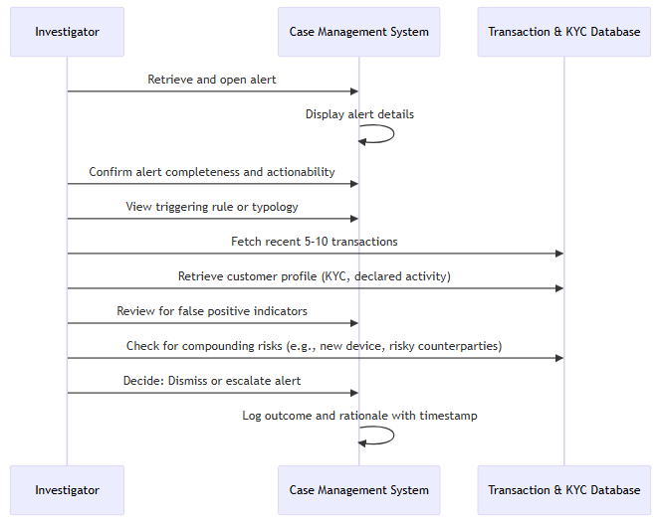

Assess Risk and Predication:
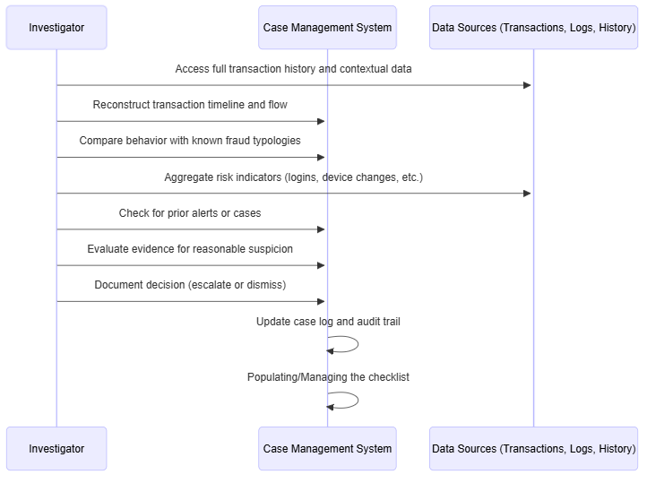

Collect and Analyze Evidence
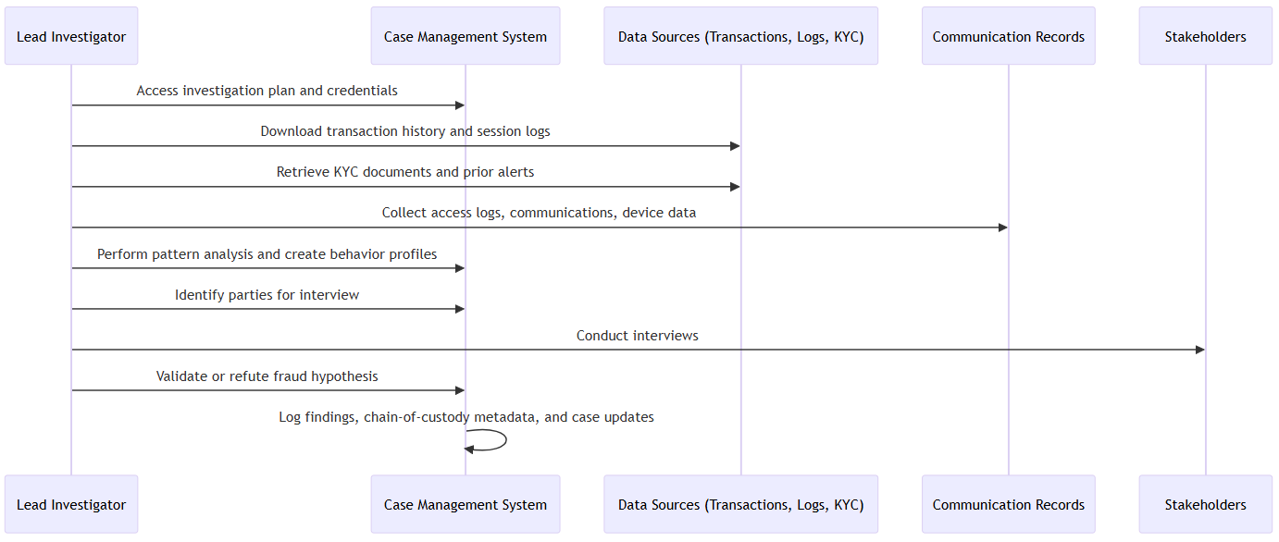

Compile Fraud Report
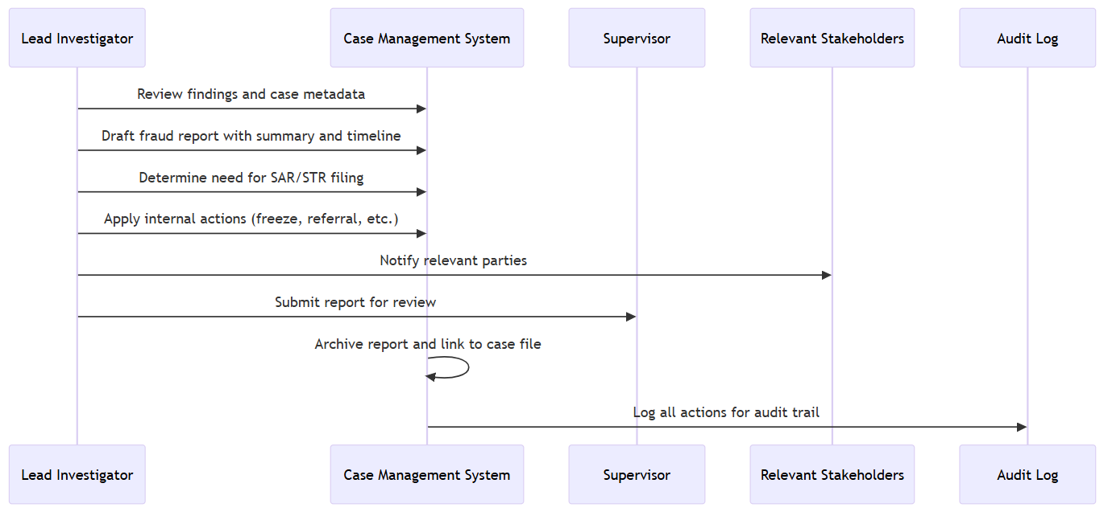

Assess AML Risk
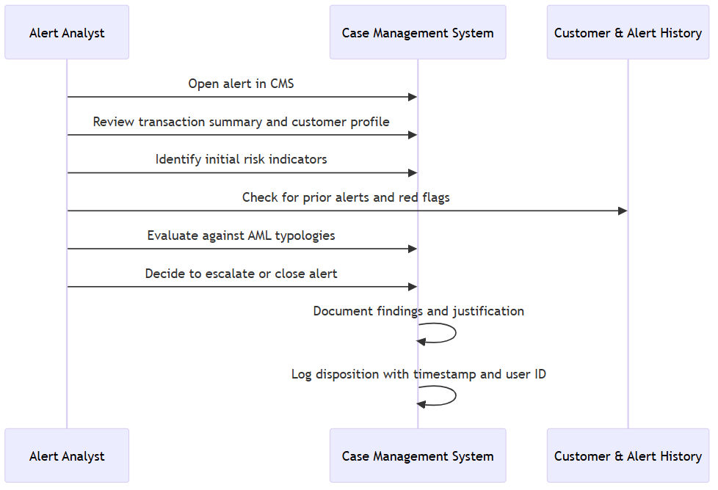

Review EDD/KYC
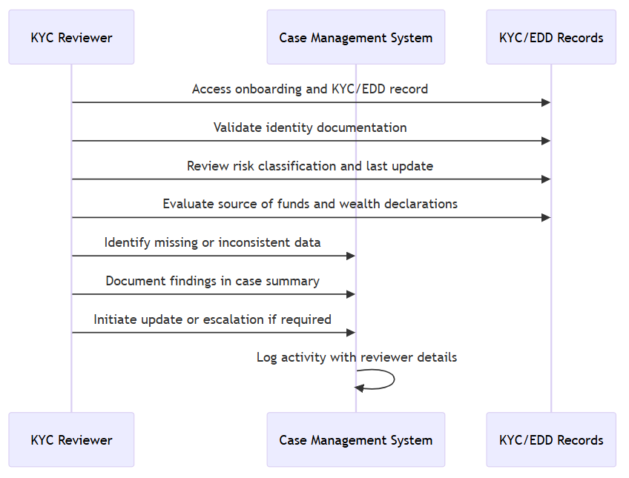

File SAR/STR

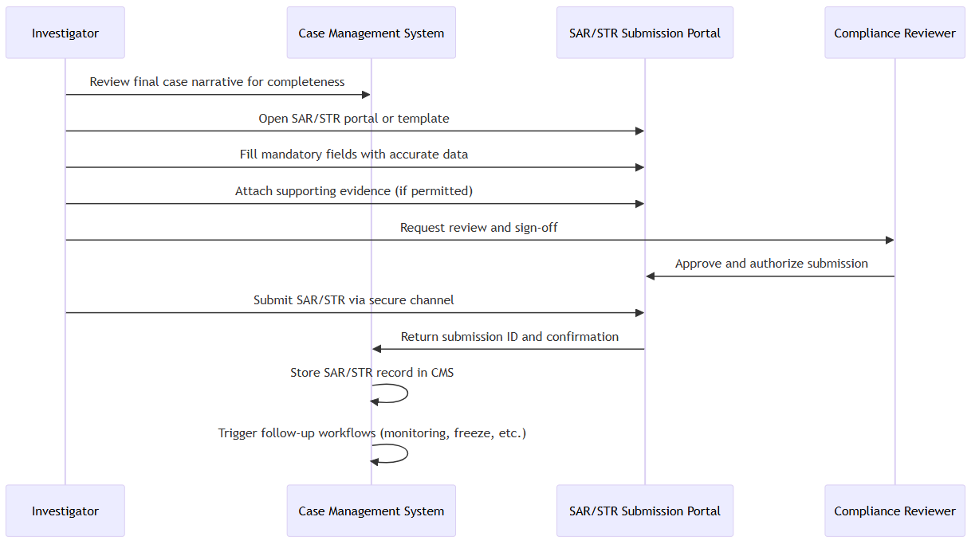

Automatically Create and Route Triage Task

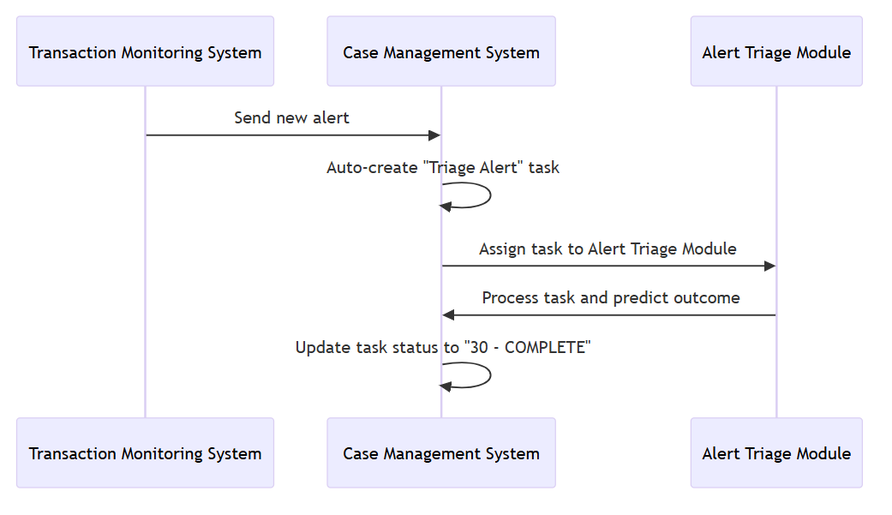

Flag Alerts for Investigation When Confidence Is Low
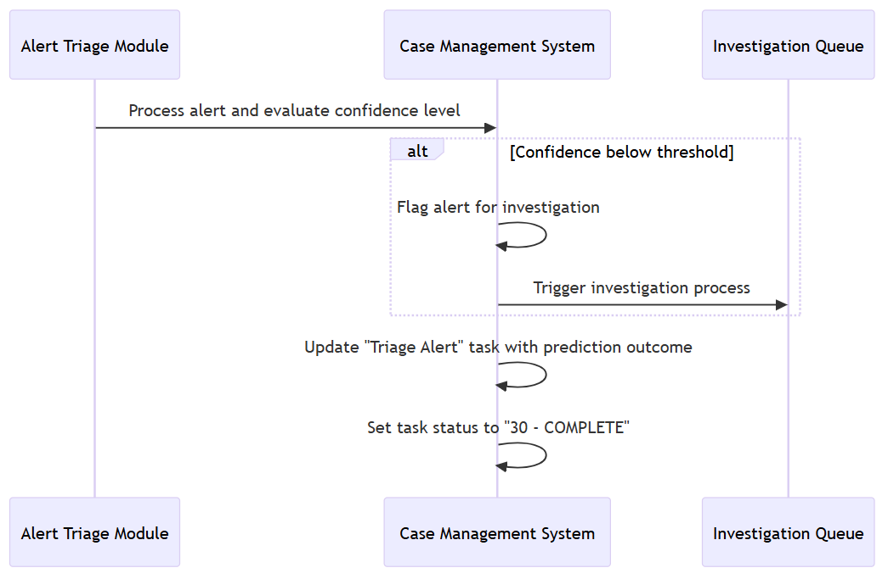

Automatically Close Alert with Confirmed Outcome
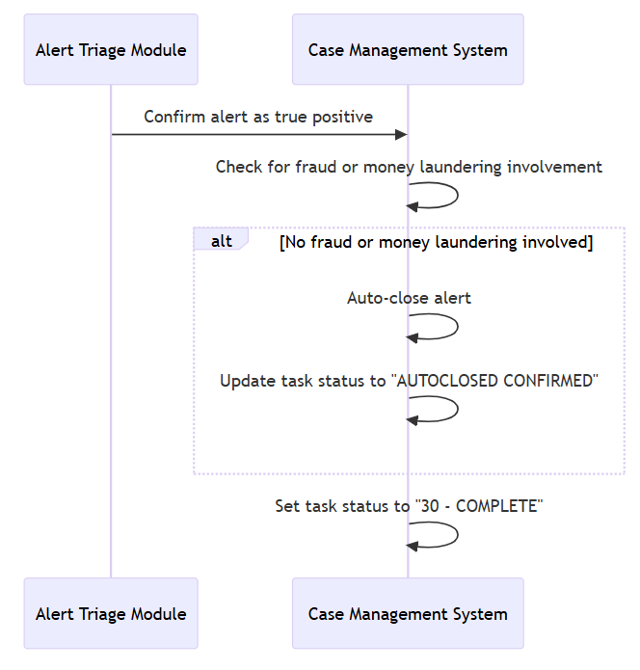

Auto-Split Cases for AML and Fraud
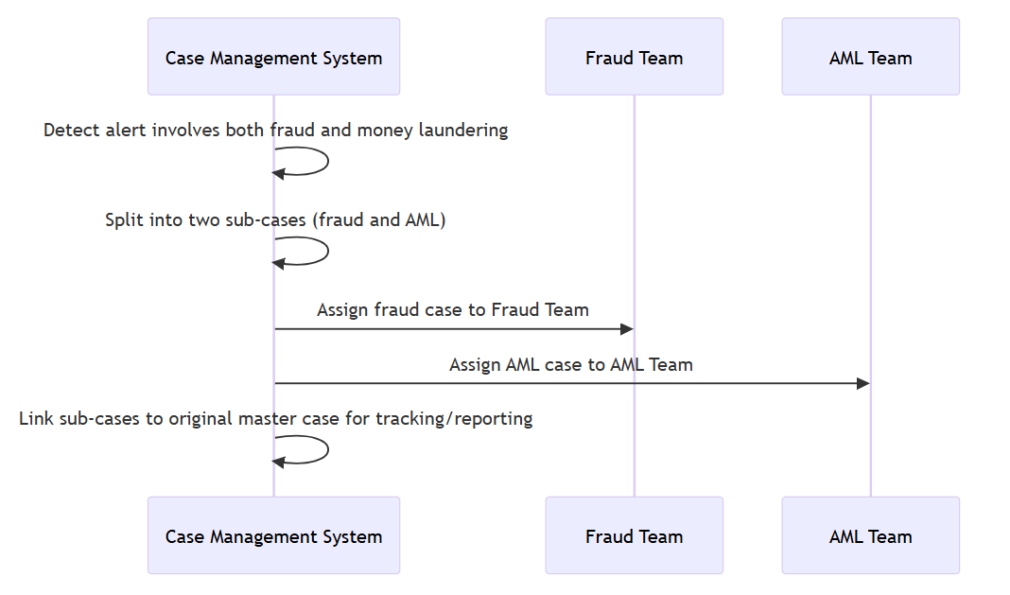

Auto-Close Alerts with False Positives
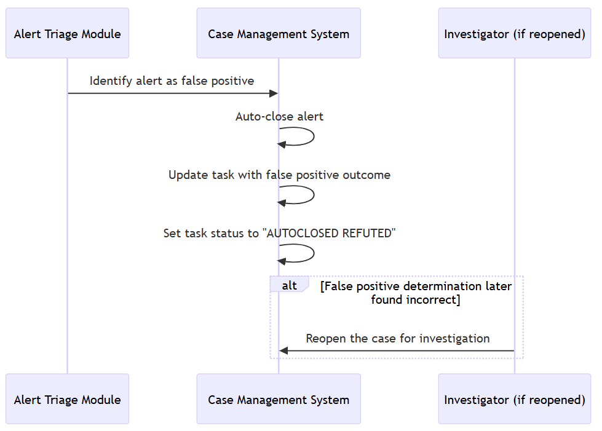

Prototype Highlights

Manual Case Creation Features
During the manual case creation process, the fraud analyst can choose typologies from a dropdown menu and then select the relevant rules associated with the case to generate an estimated typology score.
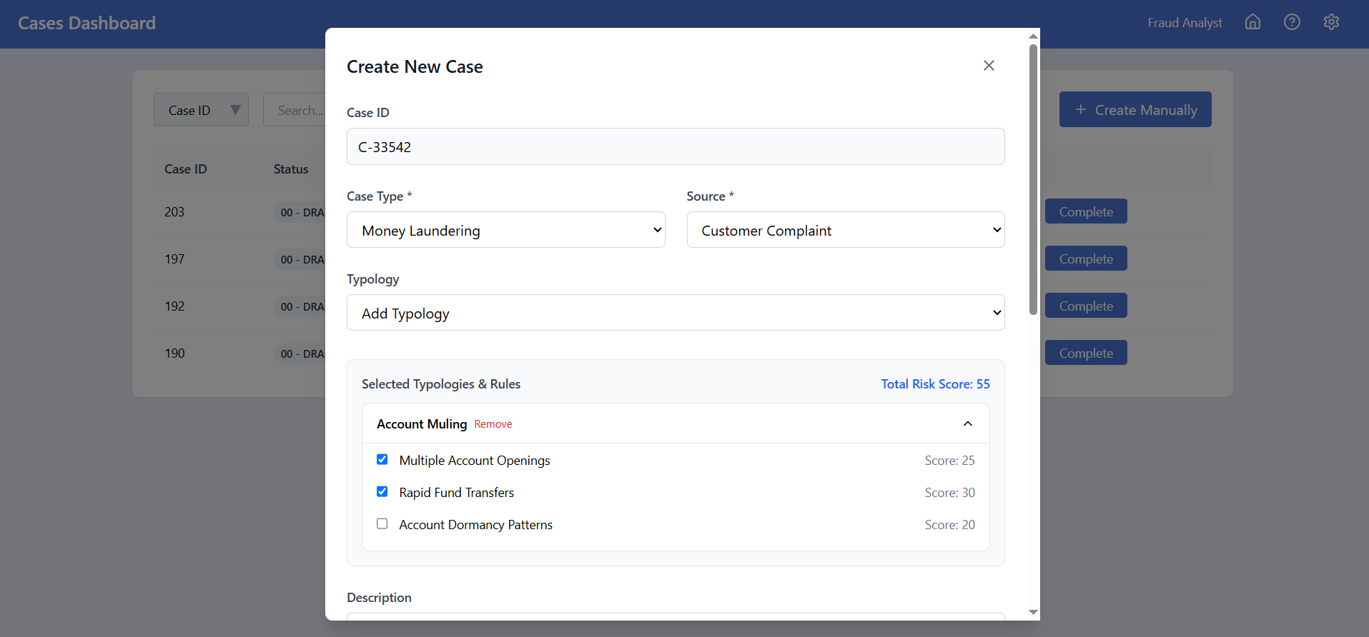

Alert Management
The Alert Management screen shows the list of Alerts with varying statuses, along with the Confidence percentages and Risk Scores. There is also an option for the Supervisors/Compliance members to download the Overturned Alerts Report for monitoring purposes. Users can also query Alerts to find a specific alert to merge with an existing case.
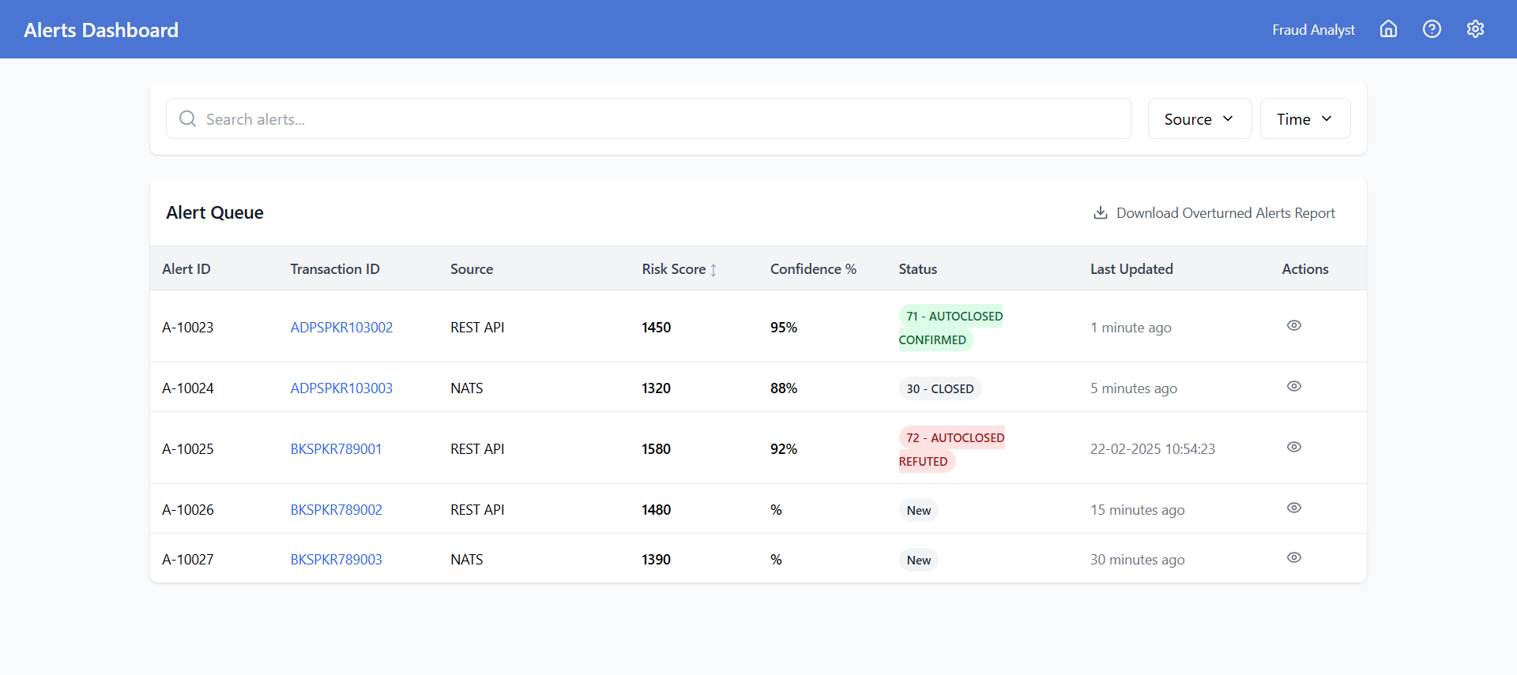

Logging Actions in an Alert
This screen displays a summary of the Alert Details for a Fraud Investigator who opts to manually review an alert and perform specific actions. The Action History contains a log of all actions automatically executed by the Alert Triage Module for that alert.
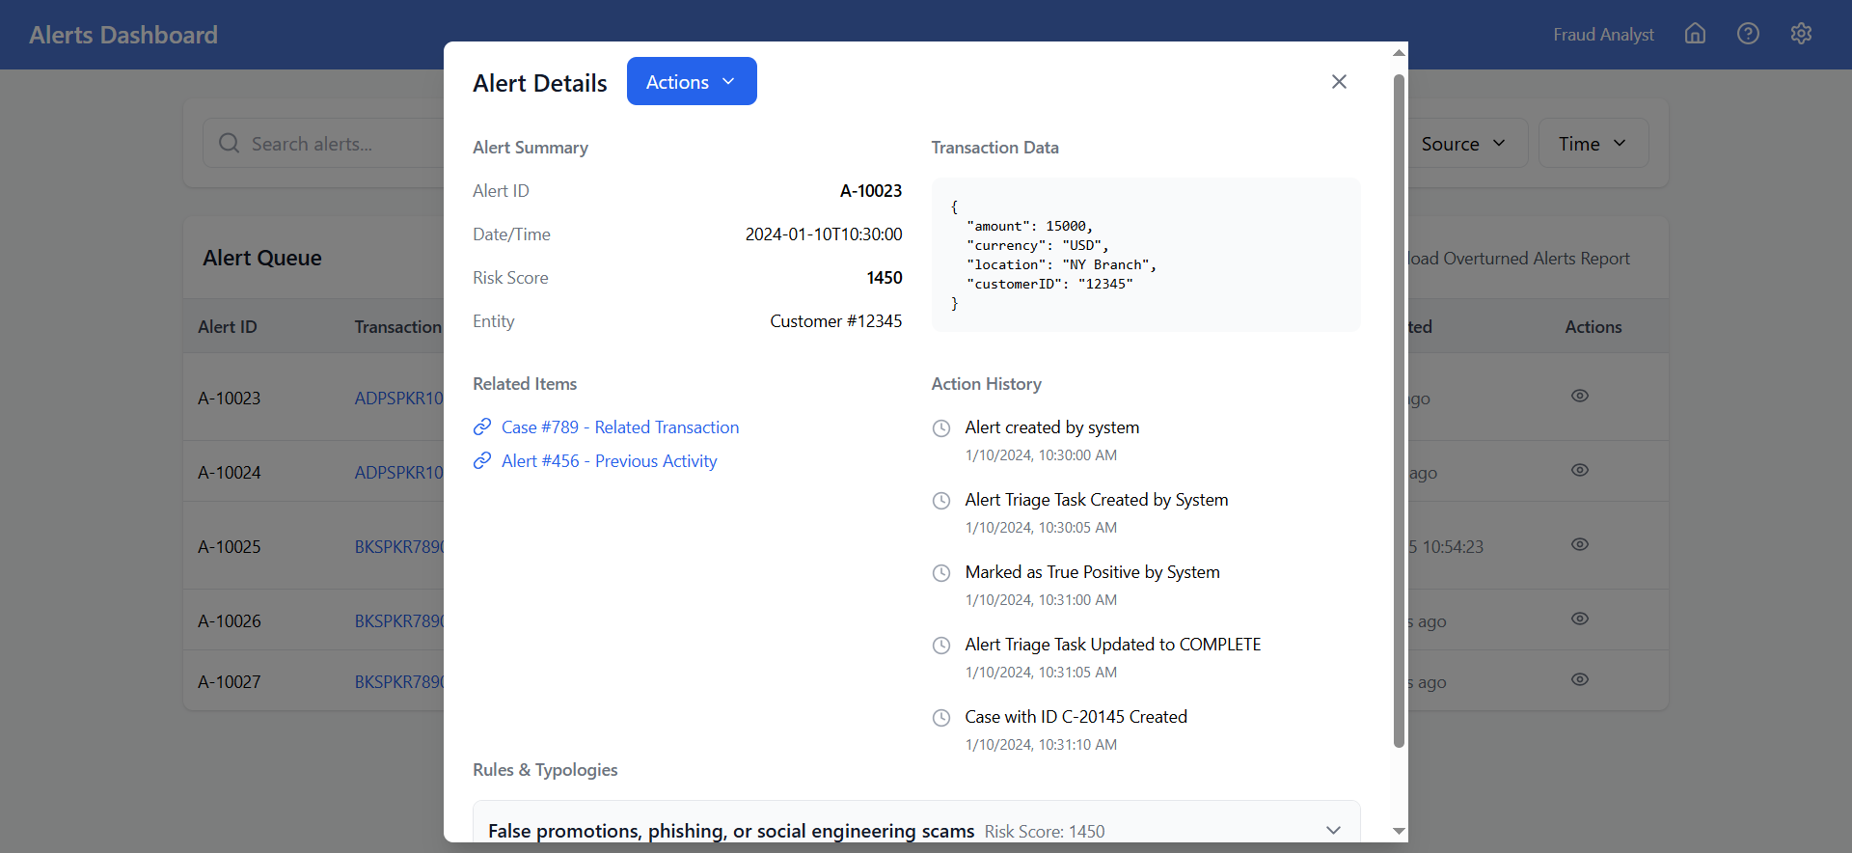

4- Escalation to Supervisor
The Fraud Analyst can escalate a case to a Supervisor whenever necessary, typically when the case requires additional expertise, approval, or when further investigation is beyond the Analyst's scope. The process is logged for audit purposes, maintaining transparency and traceability throughout the escalation workflow.
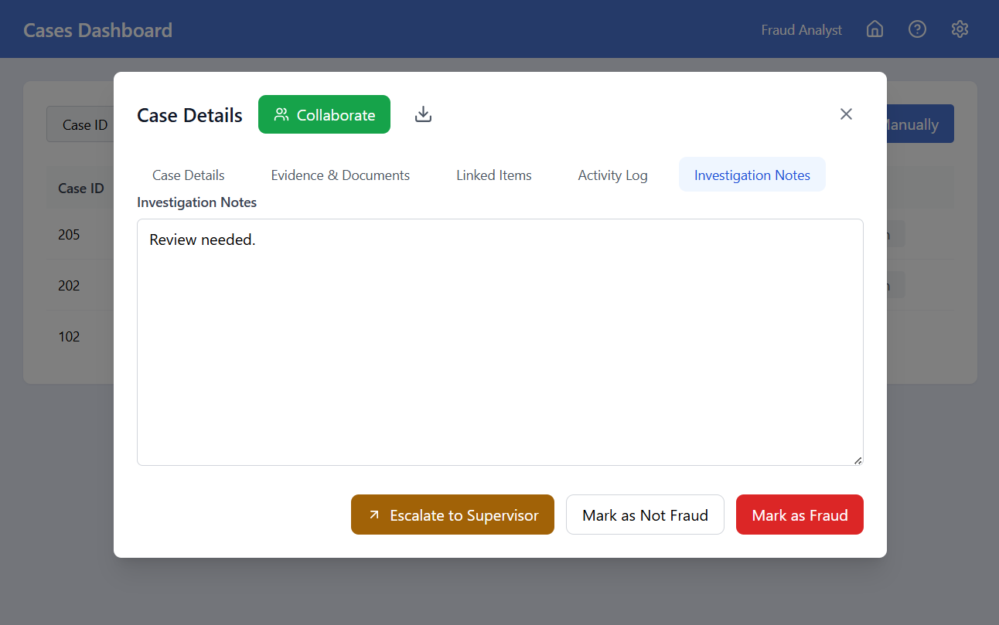

5- Reassigning a Case
The Supervisor can reassign a case from their queue to any Fraud Analyst. The CMS displays the current workload of each Fraud Analyst, assisting the Supervisor in selecting the most appropriate individual for the task based on their availability and workload.
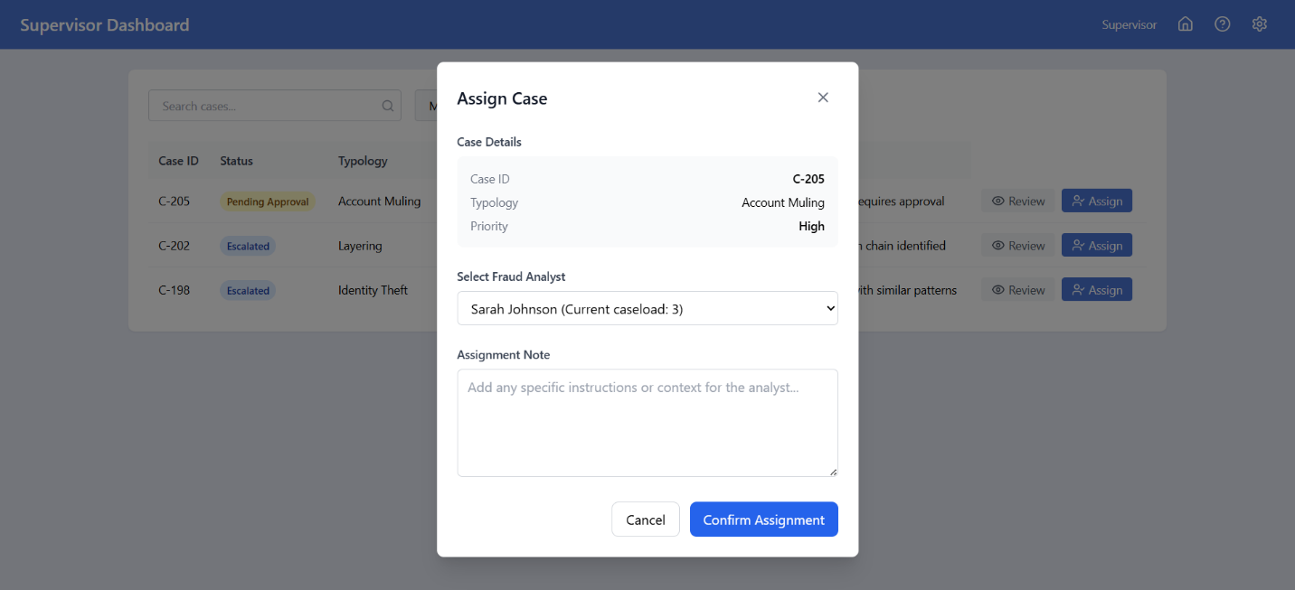

6- Case Suspension
The Supervisor has the authority to suspend a case that has been escalated to them for review. Providing a rationale for suspending the case is mandatory.
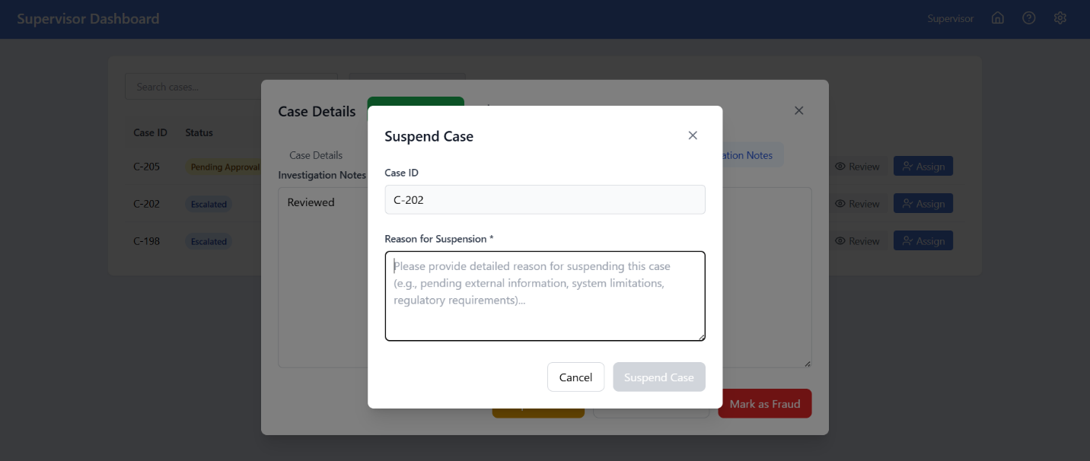
Note: For further insight into the prototype, visit CMS Prototype - Draft

Non-Functional Specifications

Auditability
In the Case Management System (CMS), auditability is implemented as a core feature to ensure full traceability of user interactions and system changes. Every action taken within the system, whether it's creating a new case, updating a task, or changing a case's status, is logged in an audit log. These logs include critical details such as the user’s identity, the specific action performed, the timestamp, and any changes made to the system. This detailed tracking ensures that all operations are fully traceable and transparent. The system is designed to maintain immutable logs that cannot be altered or deleted, ensuring that the history of every event is preserved for review. These logs are stored securely in compliance with regulatory standards, including GDPR and ISO 27001, providing both operational transparency and the ability to track compliance with internal and external policies.

Change Controls for Fields
To ensure the integrity of data and prevent unauthorized alterations, the CMS enforces change control mechanisms for system fields and configurations. Only users with appropriate administrative privileges, such as system administrators, are authorized to modify field definitions or system configurations. Whenever a change is made to a field—such as altering field types, updating dropdown values, or adjusting mandatory field statuses—the system triggers an approval process. This ensures that the change is reviewed, validated, and properly documented before being implemented. Each field modification is captured in both audit logs and system logs, detailing who made the change, when it was made, and the reason behind the alteration. This structured change control process helps prevent unauthorized changes and maintains the consistency and reliability of the system's data structure.

Transactional History for Entities
The CMS is designed to preserve a complete transactional history for every entity, such as a case or task, to maintain a detailed record of its lifecycle. Each entity, from its creation to closure, is tracked in the system with every action taken being recorded in chronological order. The transactional history includes key events such as task assignments, status changes, evidence uploads, and case reassignments. For example, when a case is created, the system logs its initial details, and as the case progresses, subsequent actions—such as updates, task completions, or supervisor approvals—are recorded. The historical data for each entity is stored in a structured format, allowing for easy retrieval and review at any point in the entity’s lifecycle. This provides an auditable trail of all decisions and actions taken, ensuring that all steps in the case management process are documented and can be verified. The ability to trace an entity’s entire history supports both operational transparency and compliance with regulatory requirements.

